Report Lab04
Name: Nguyễn Ngọc Linh
ID: 20235520

- Source code
  - Aims class

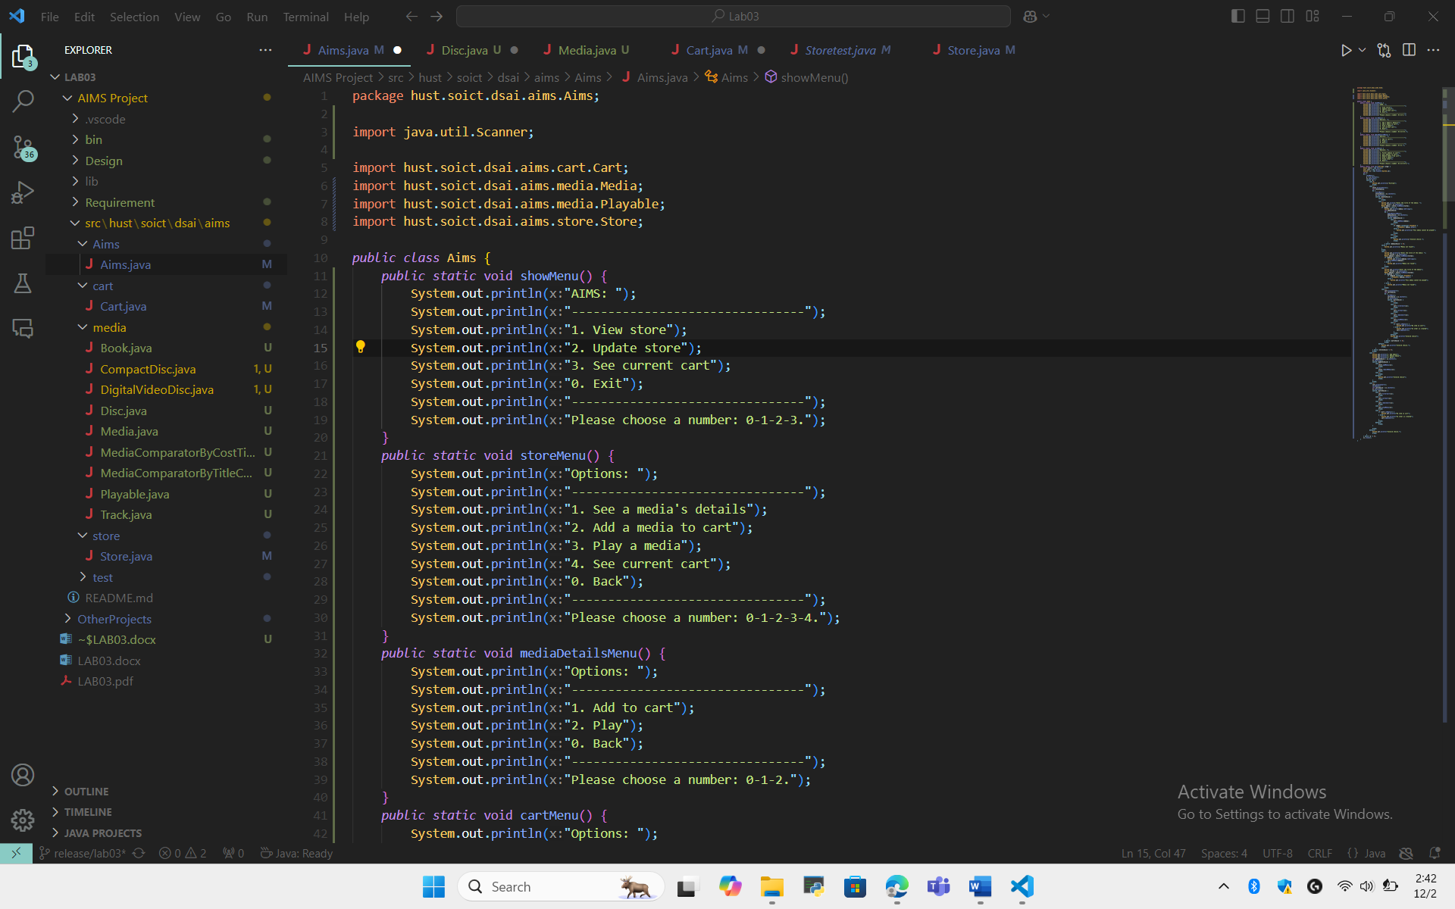
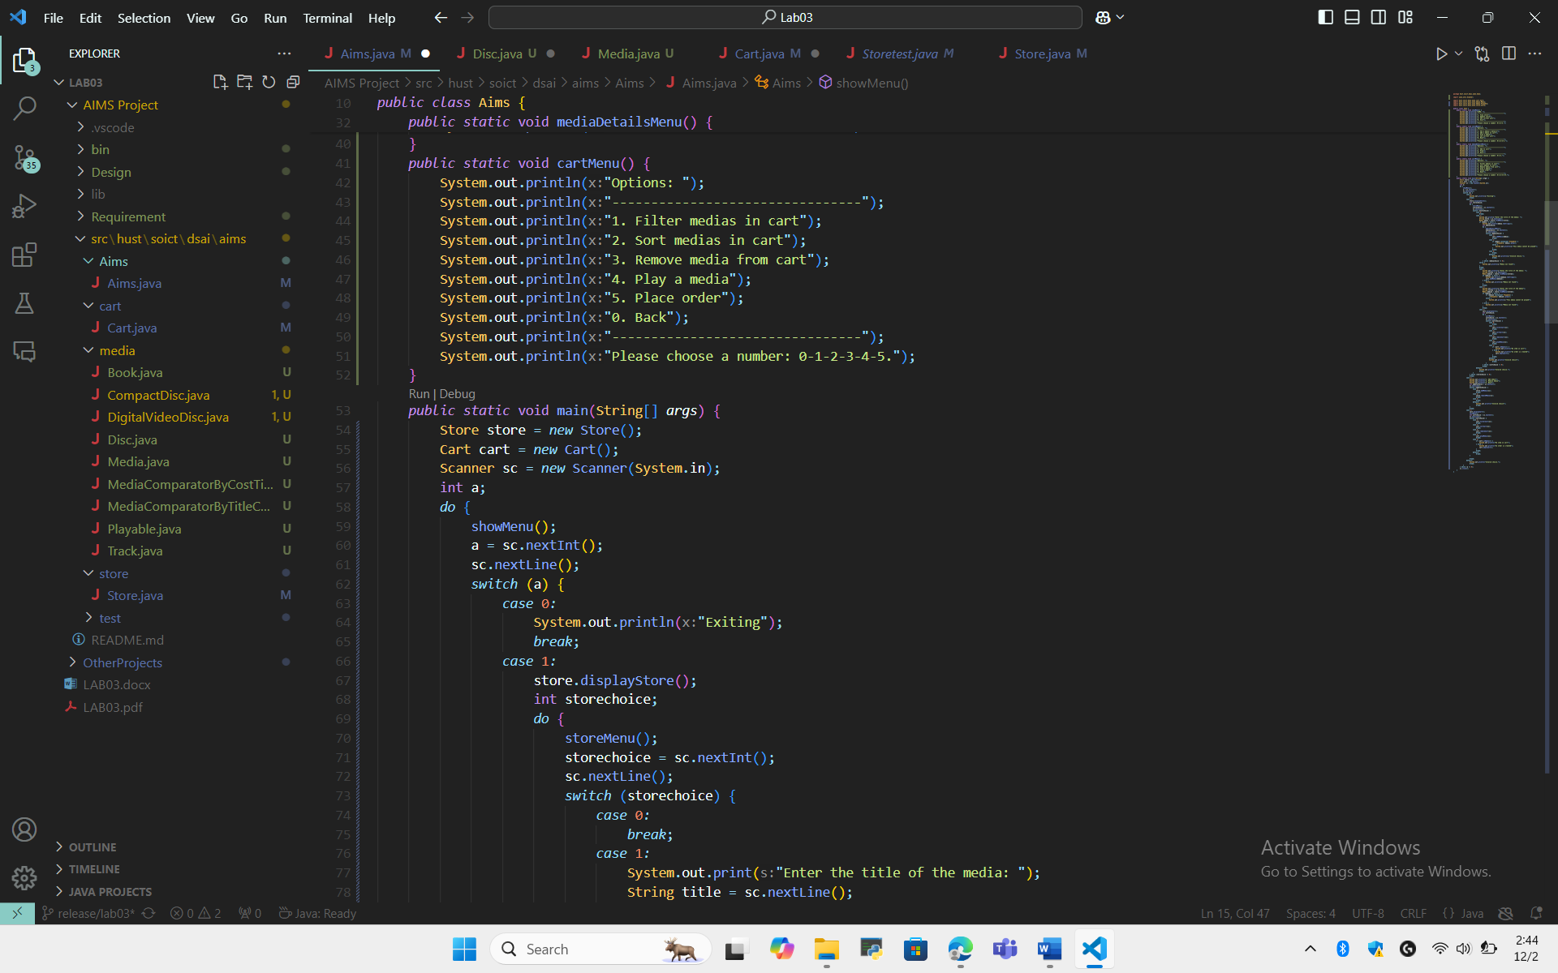
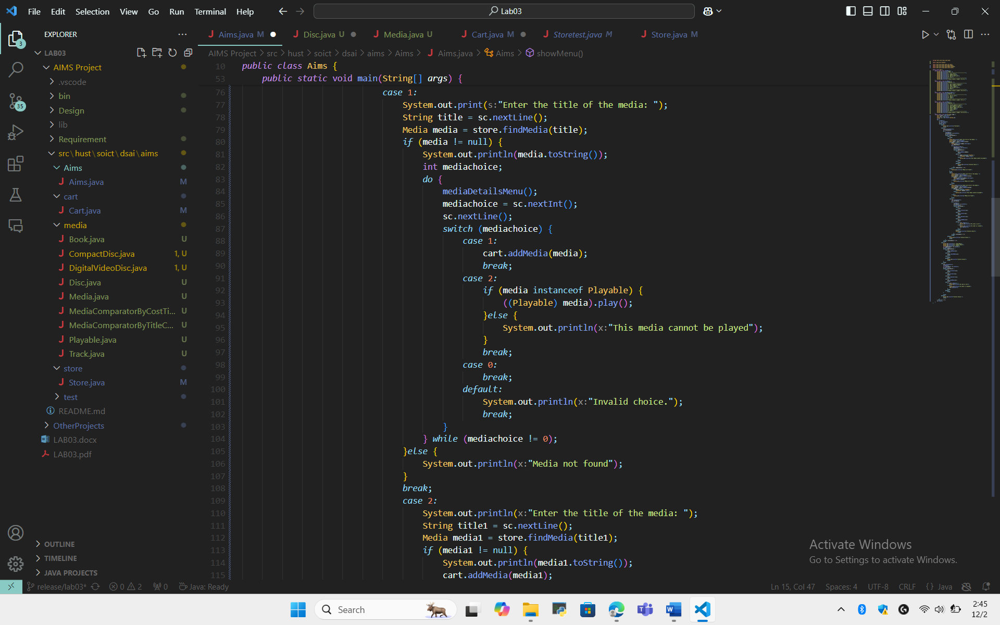
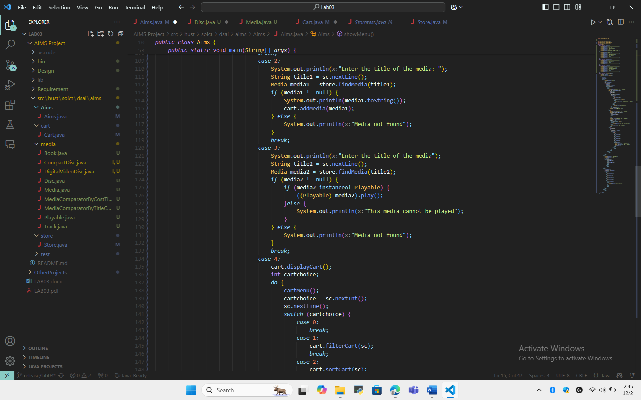
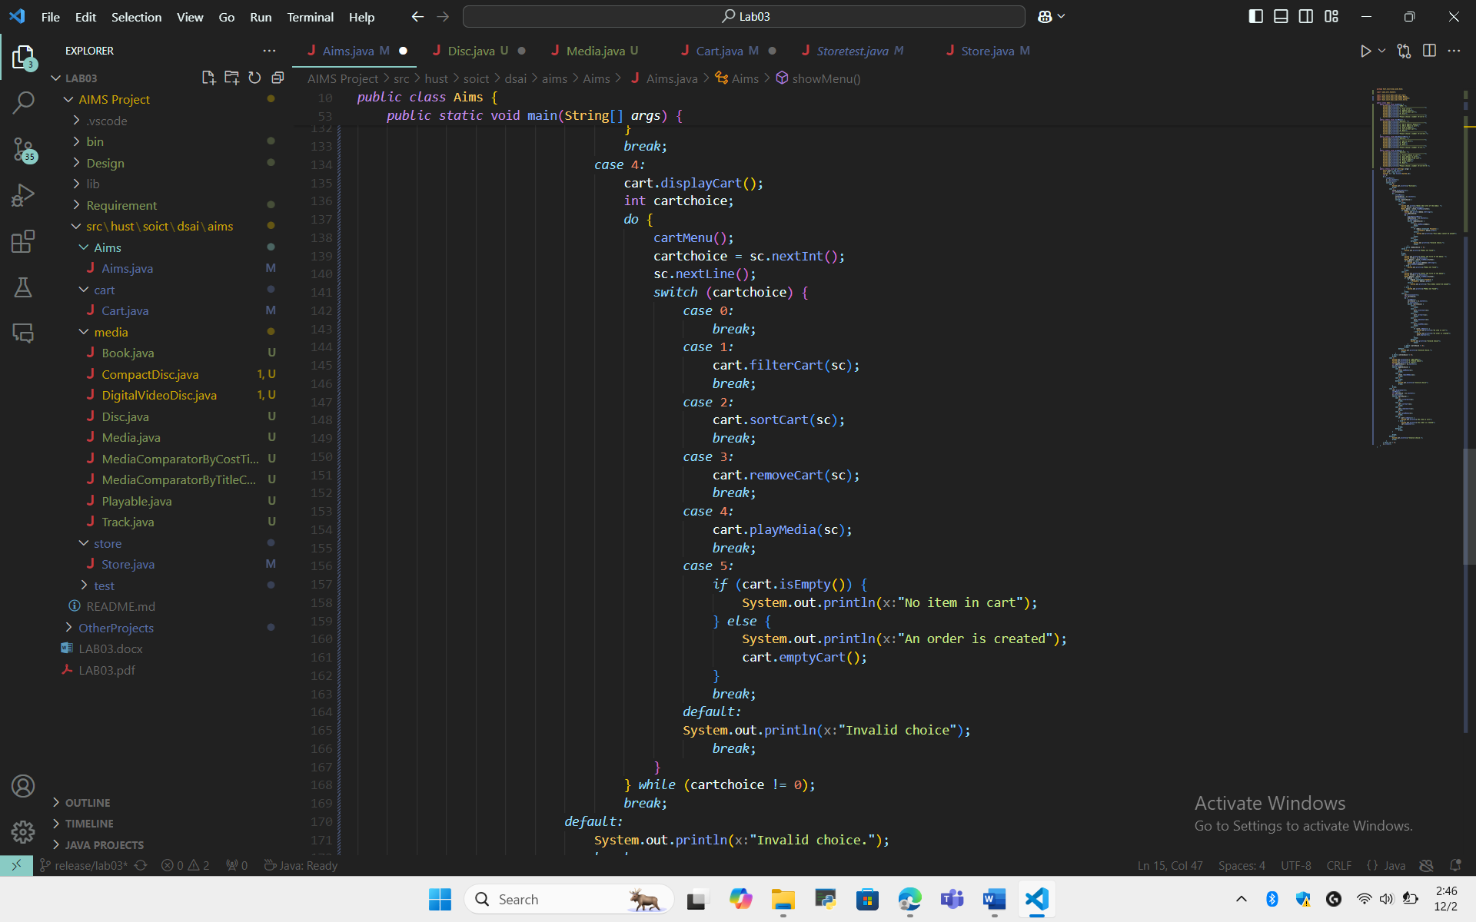
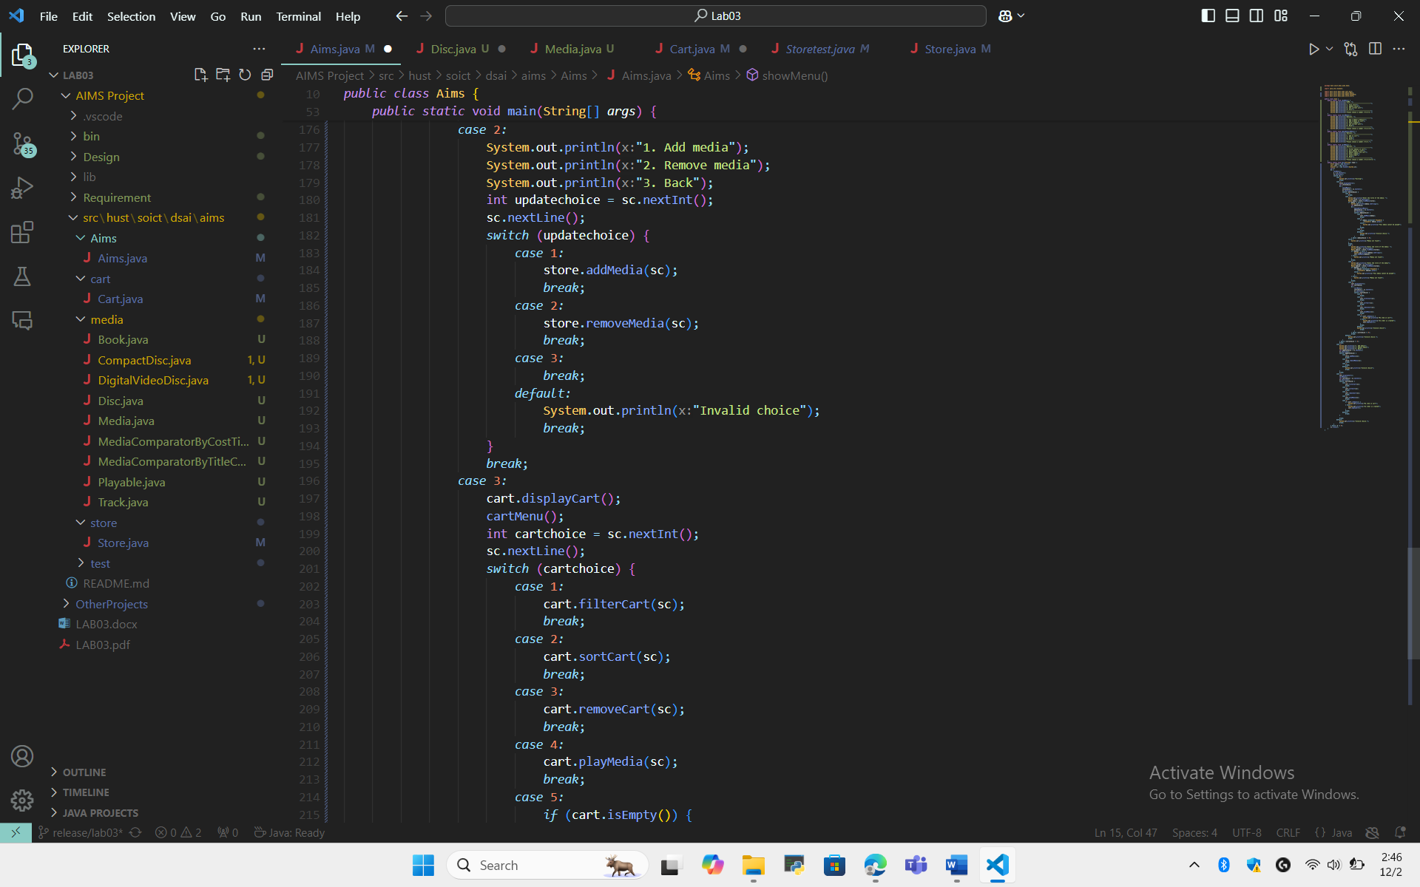
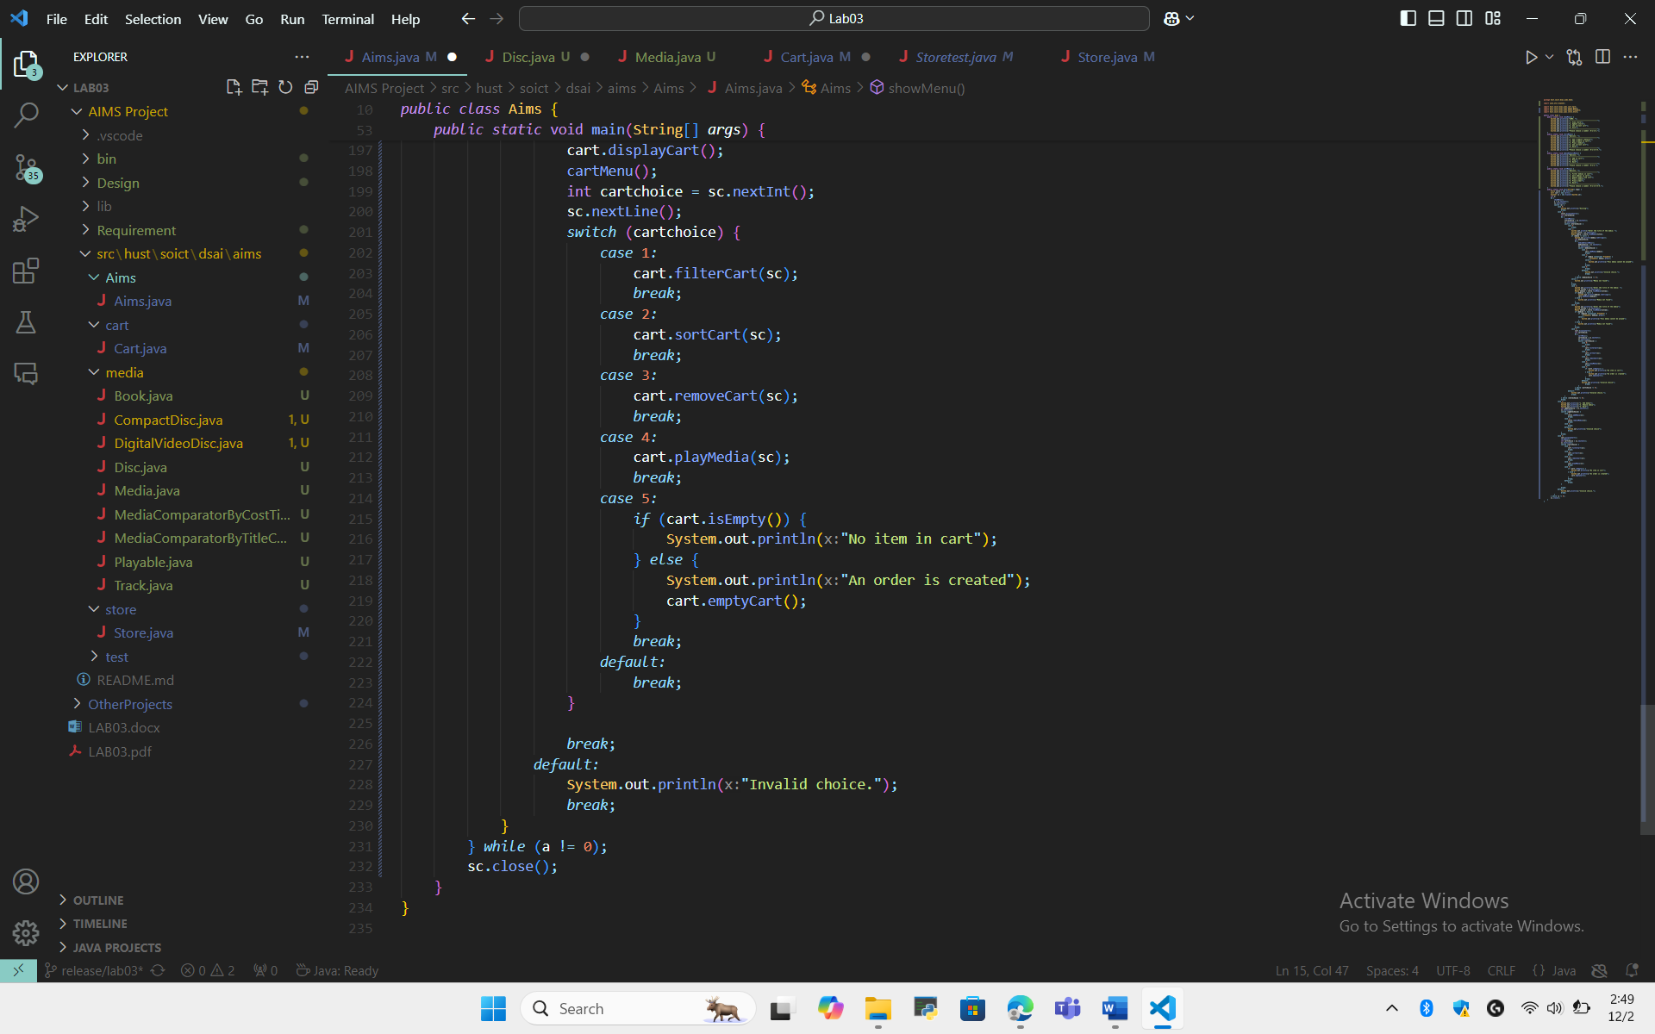

  - Cart class
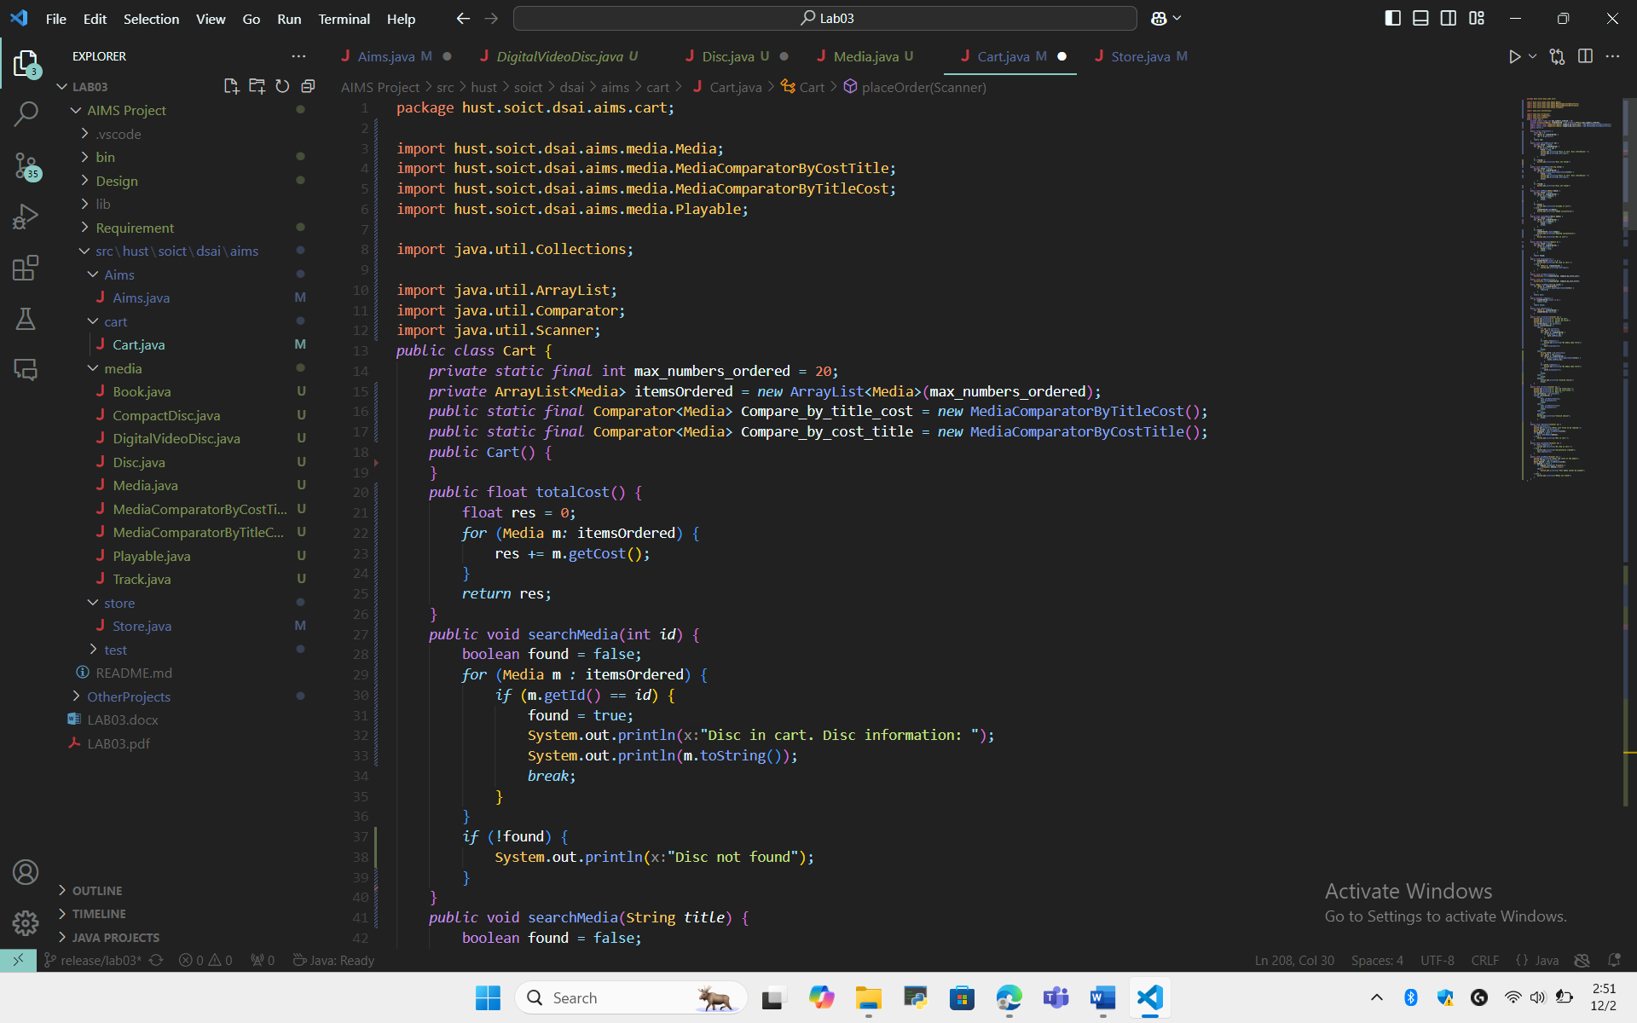
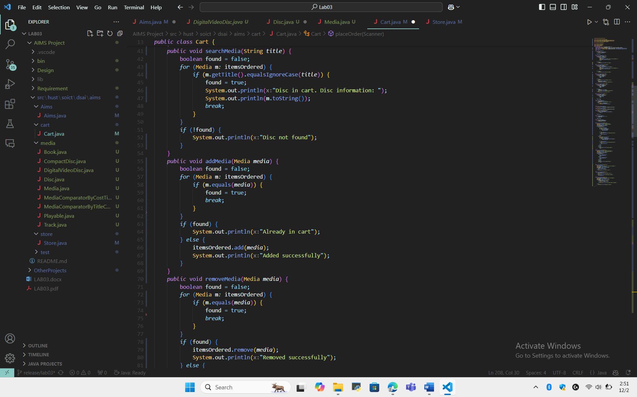
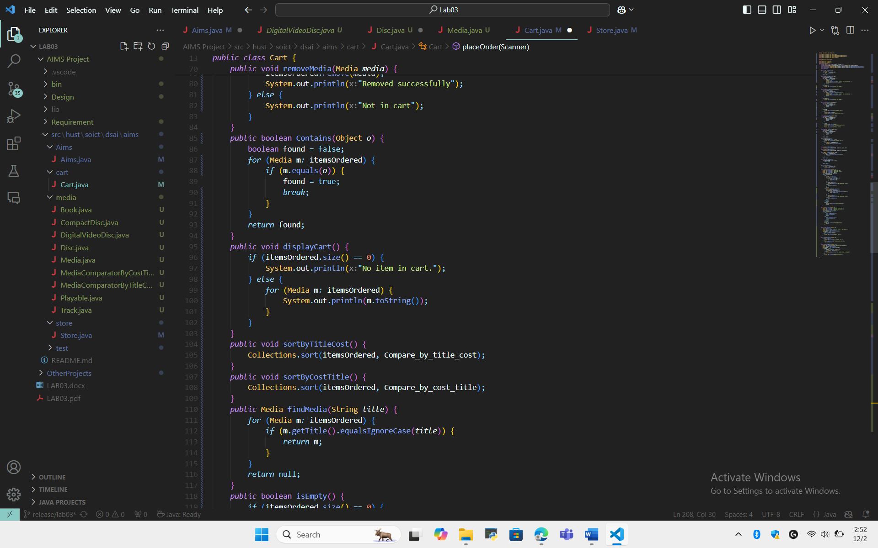
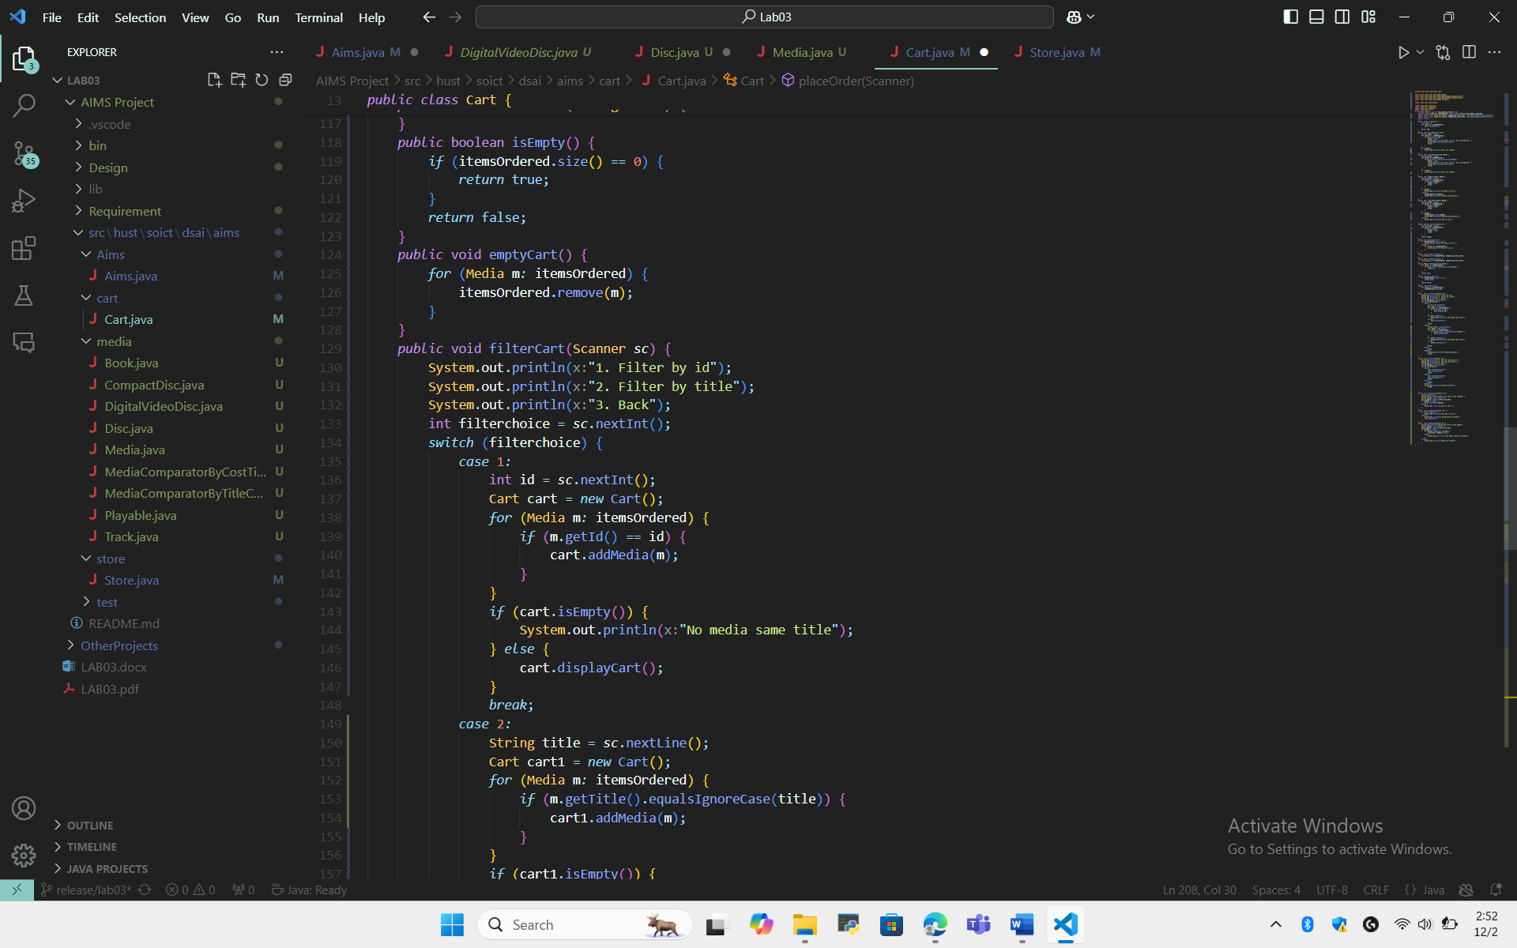
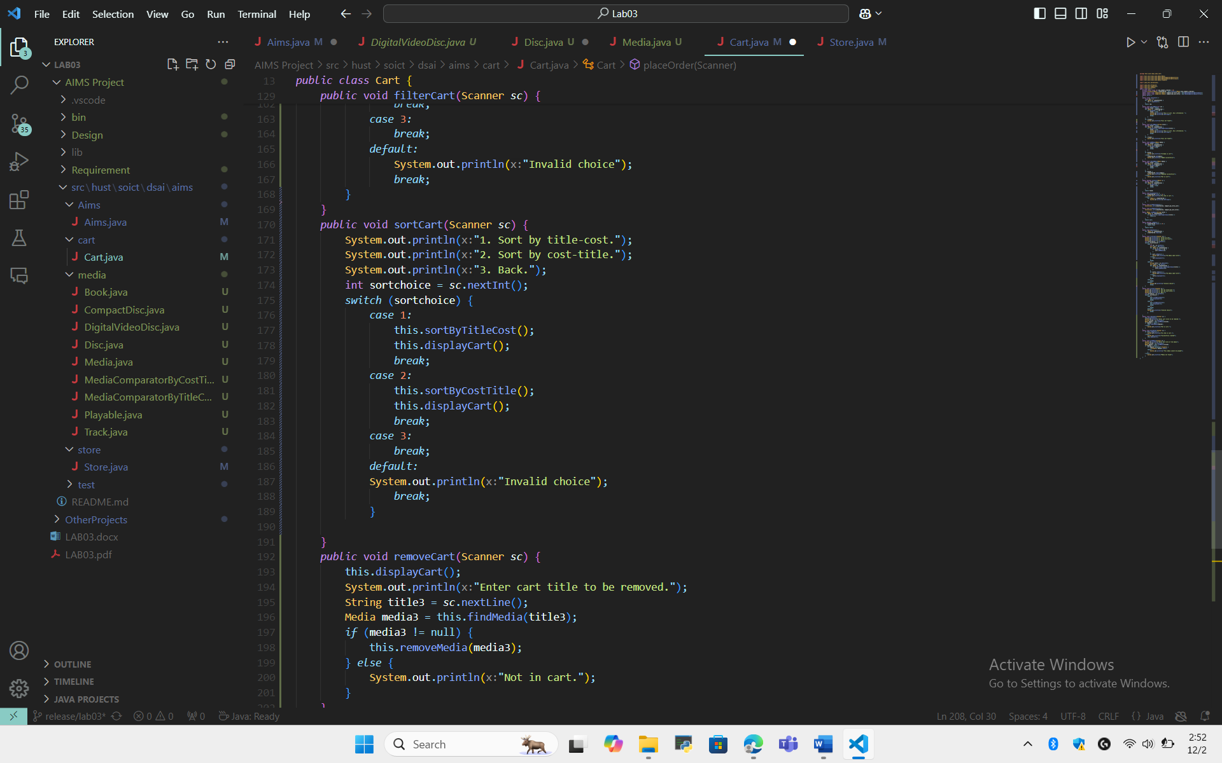
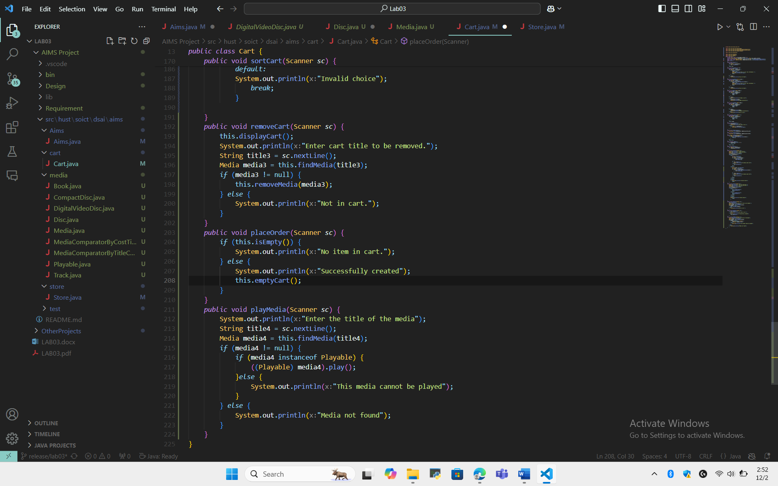

  - Store class
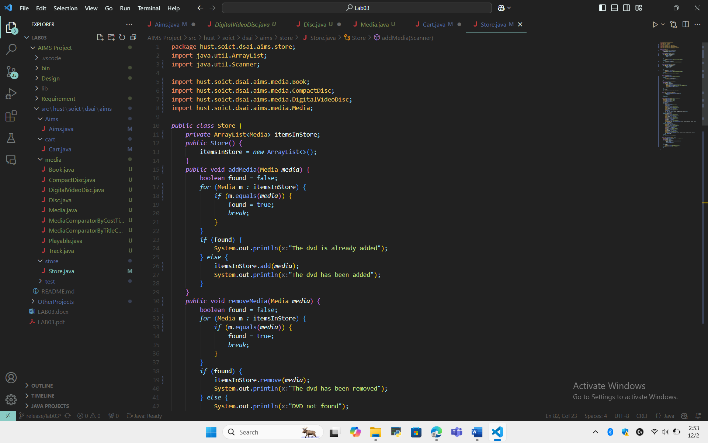
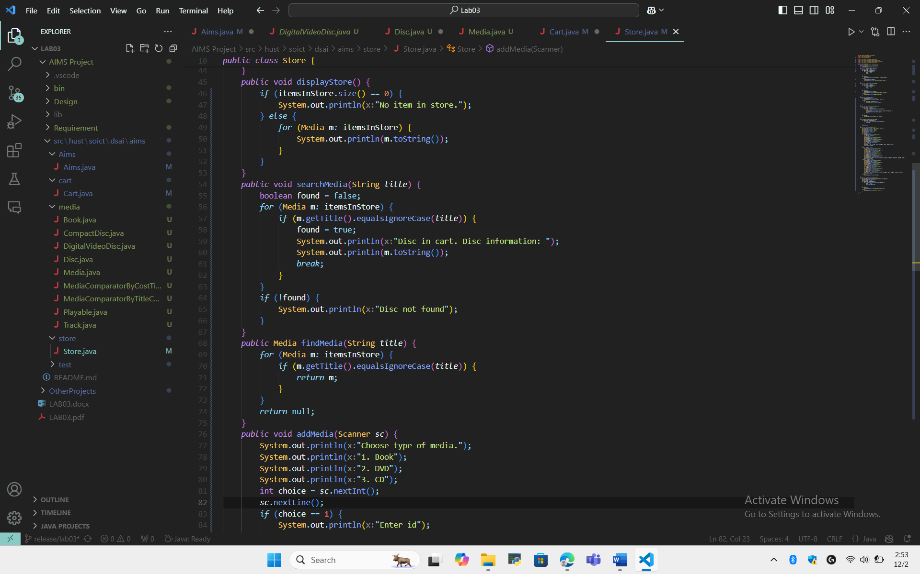
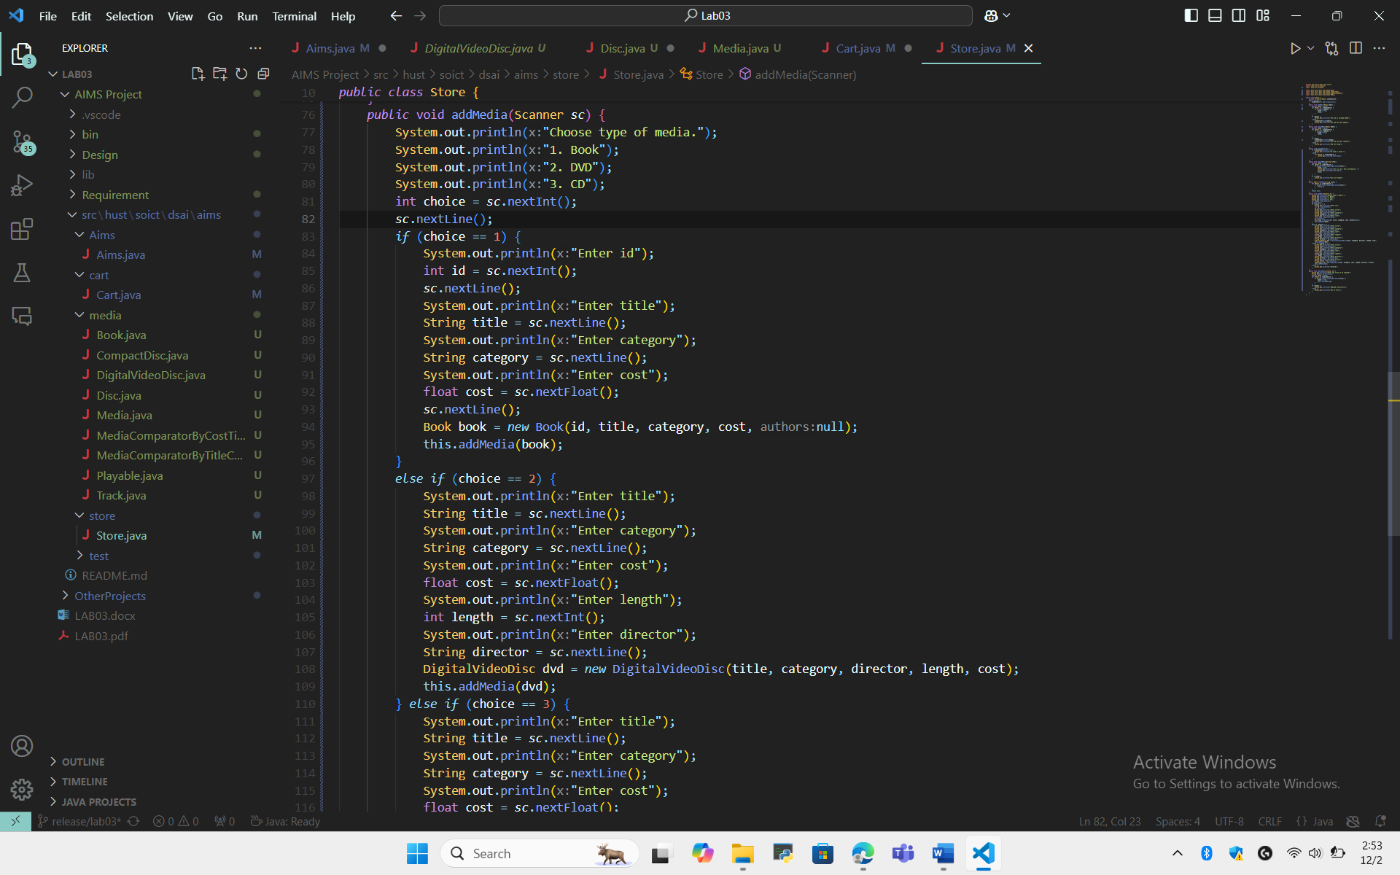
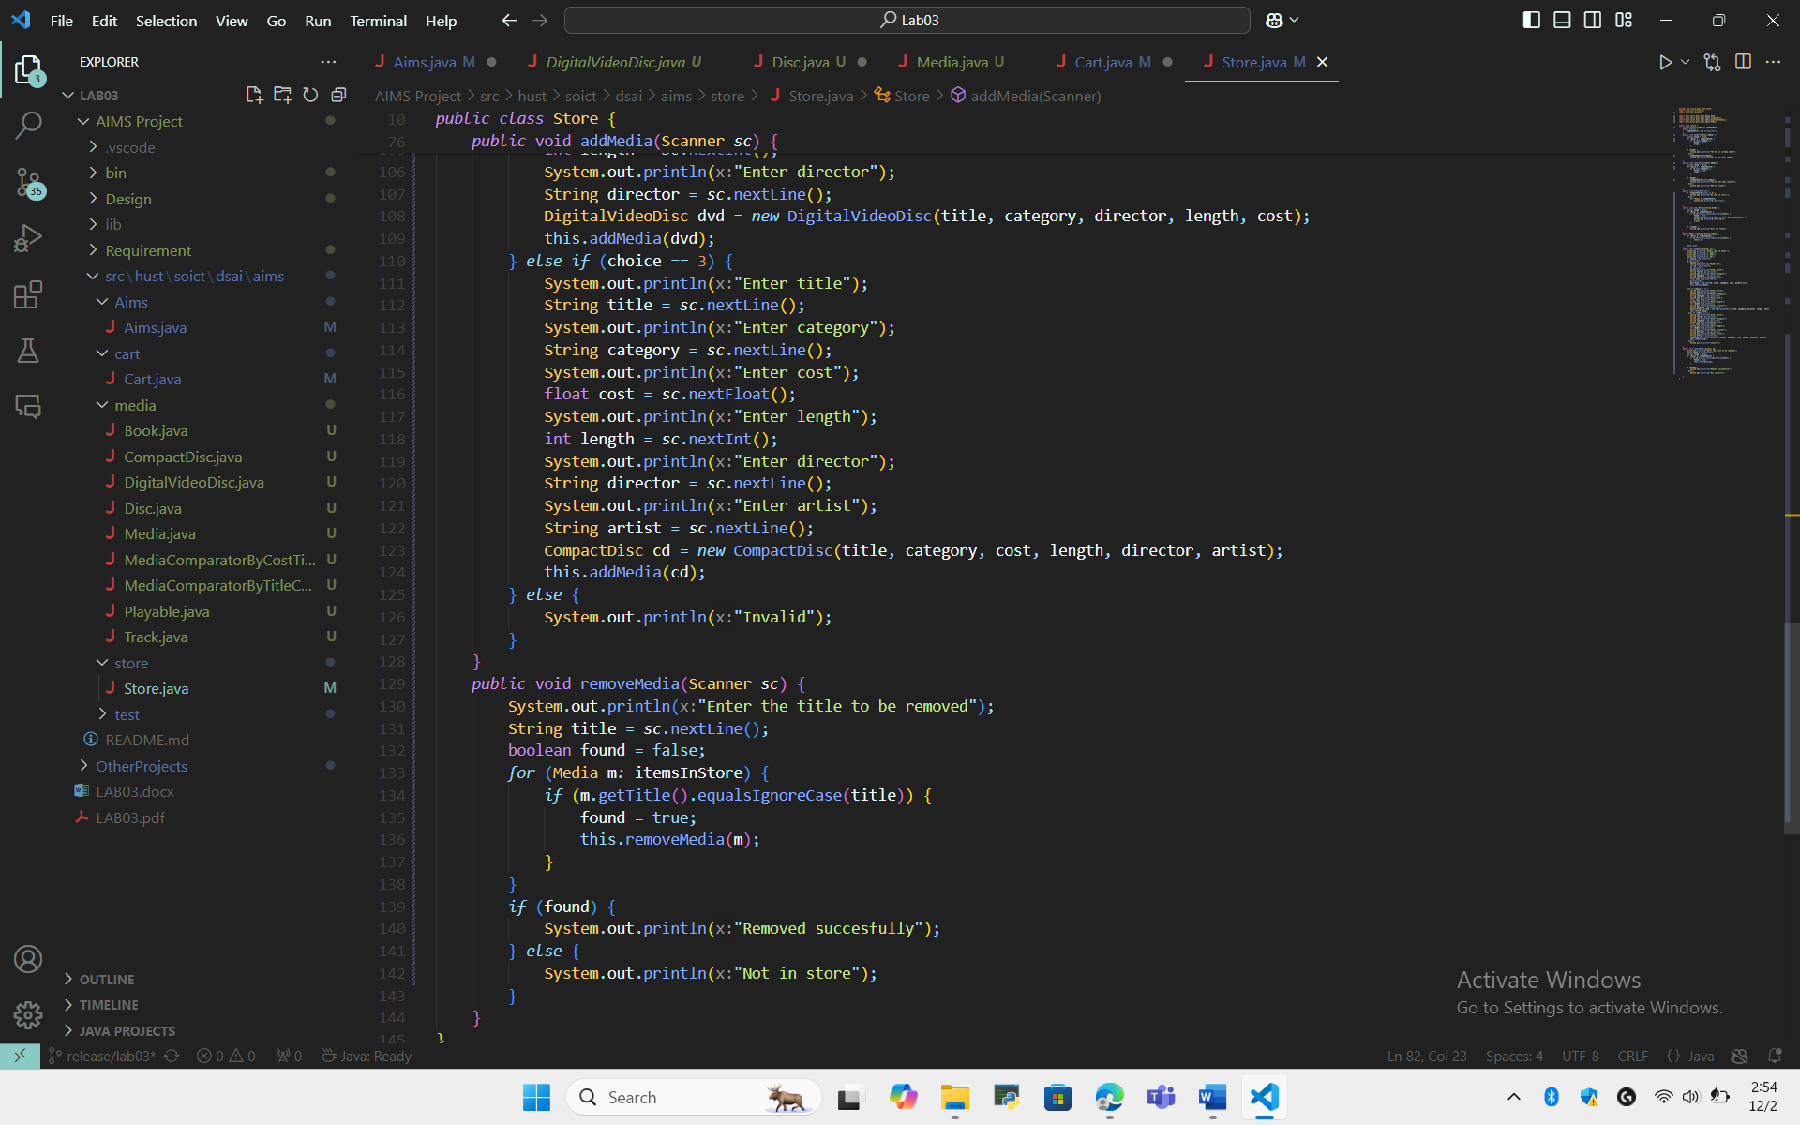

  - Media class
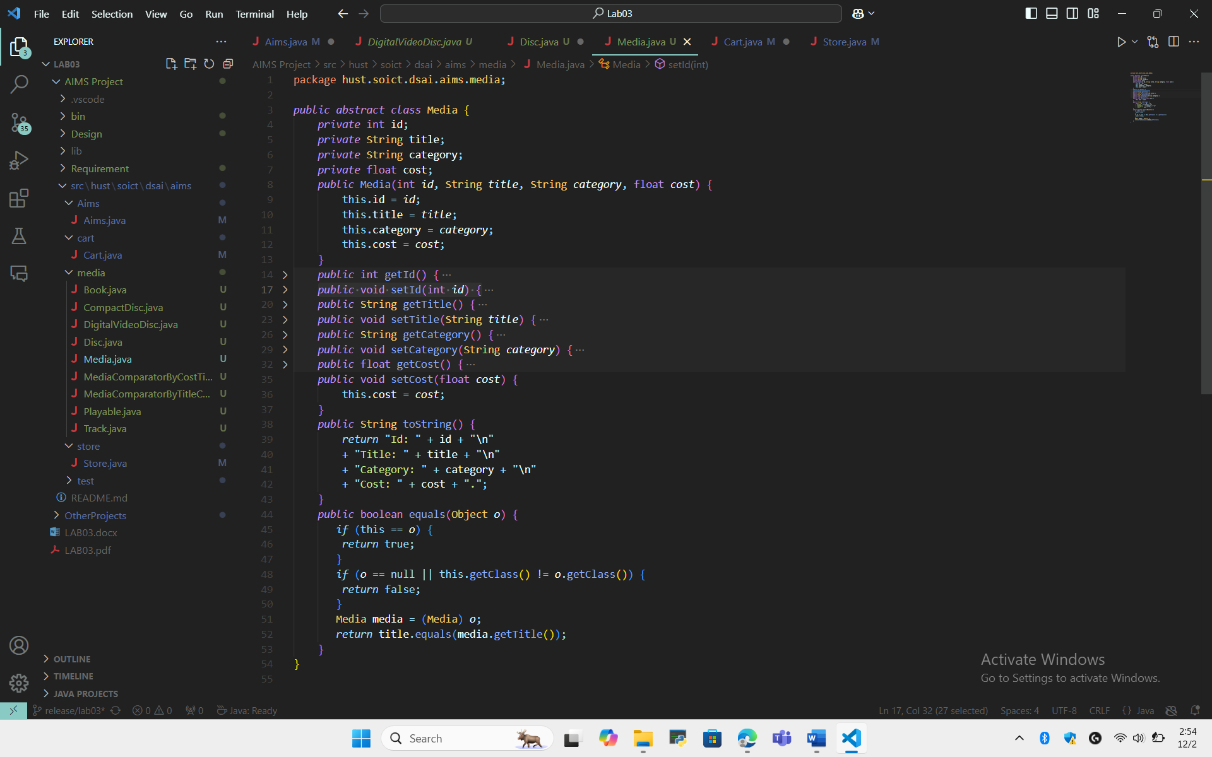
  - Disc class
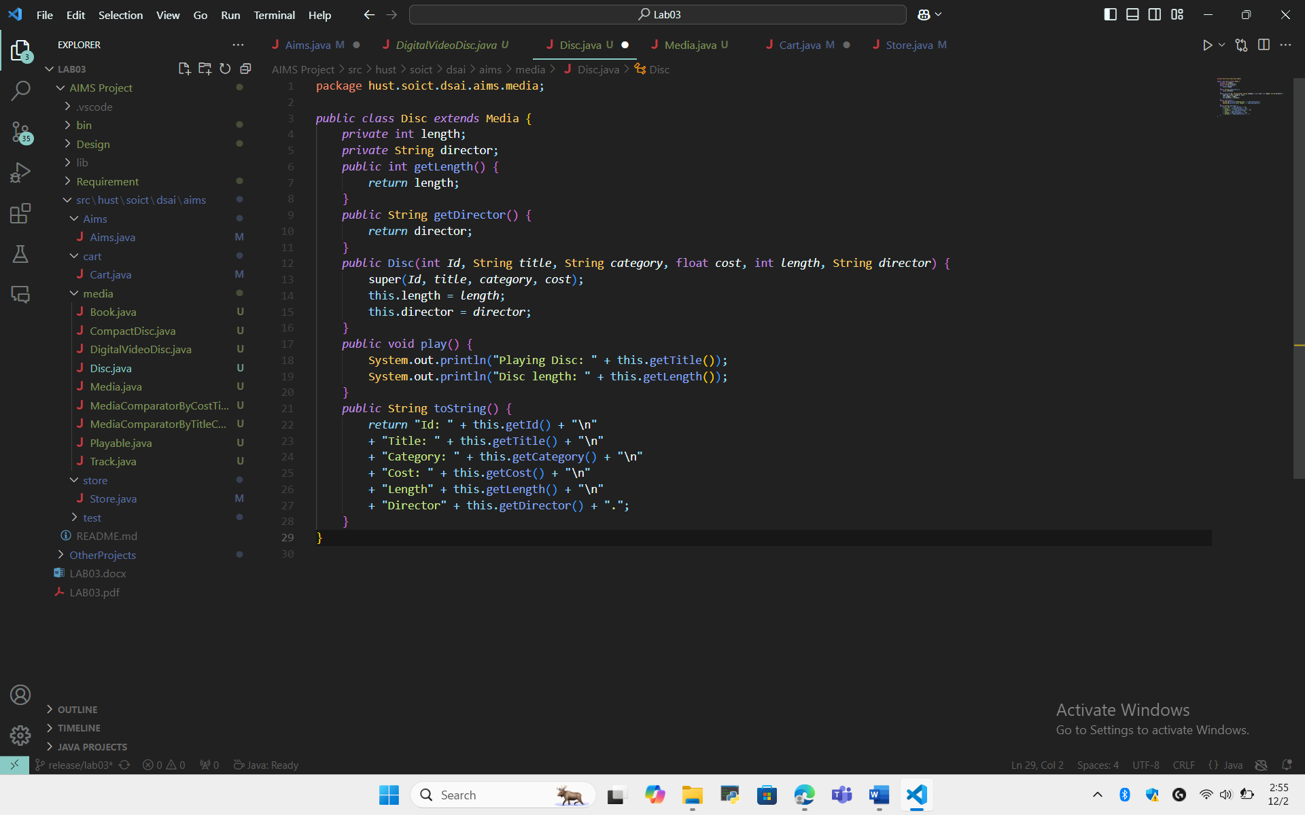

  - Dvd class
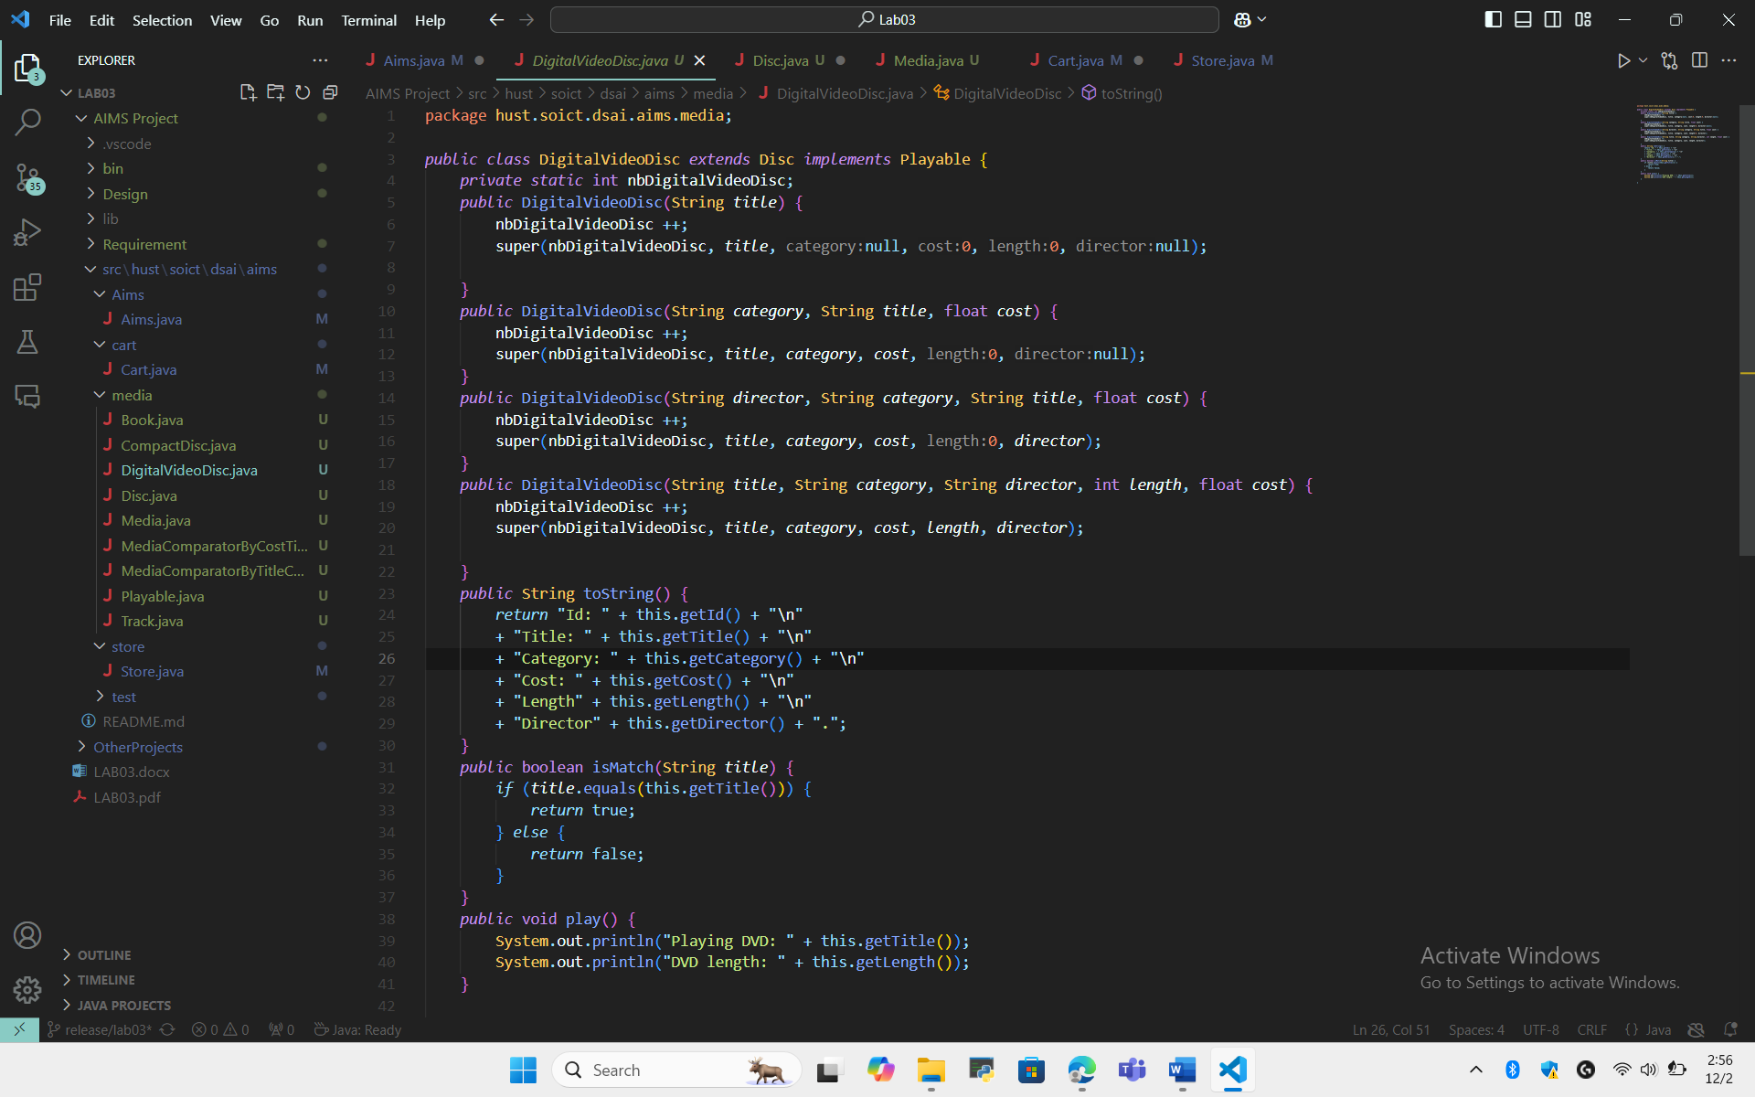
  - CD class
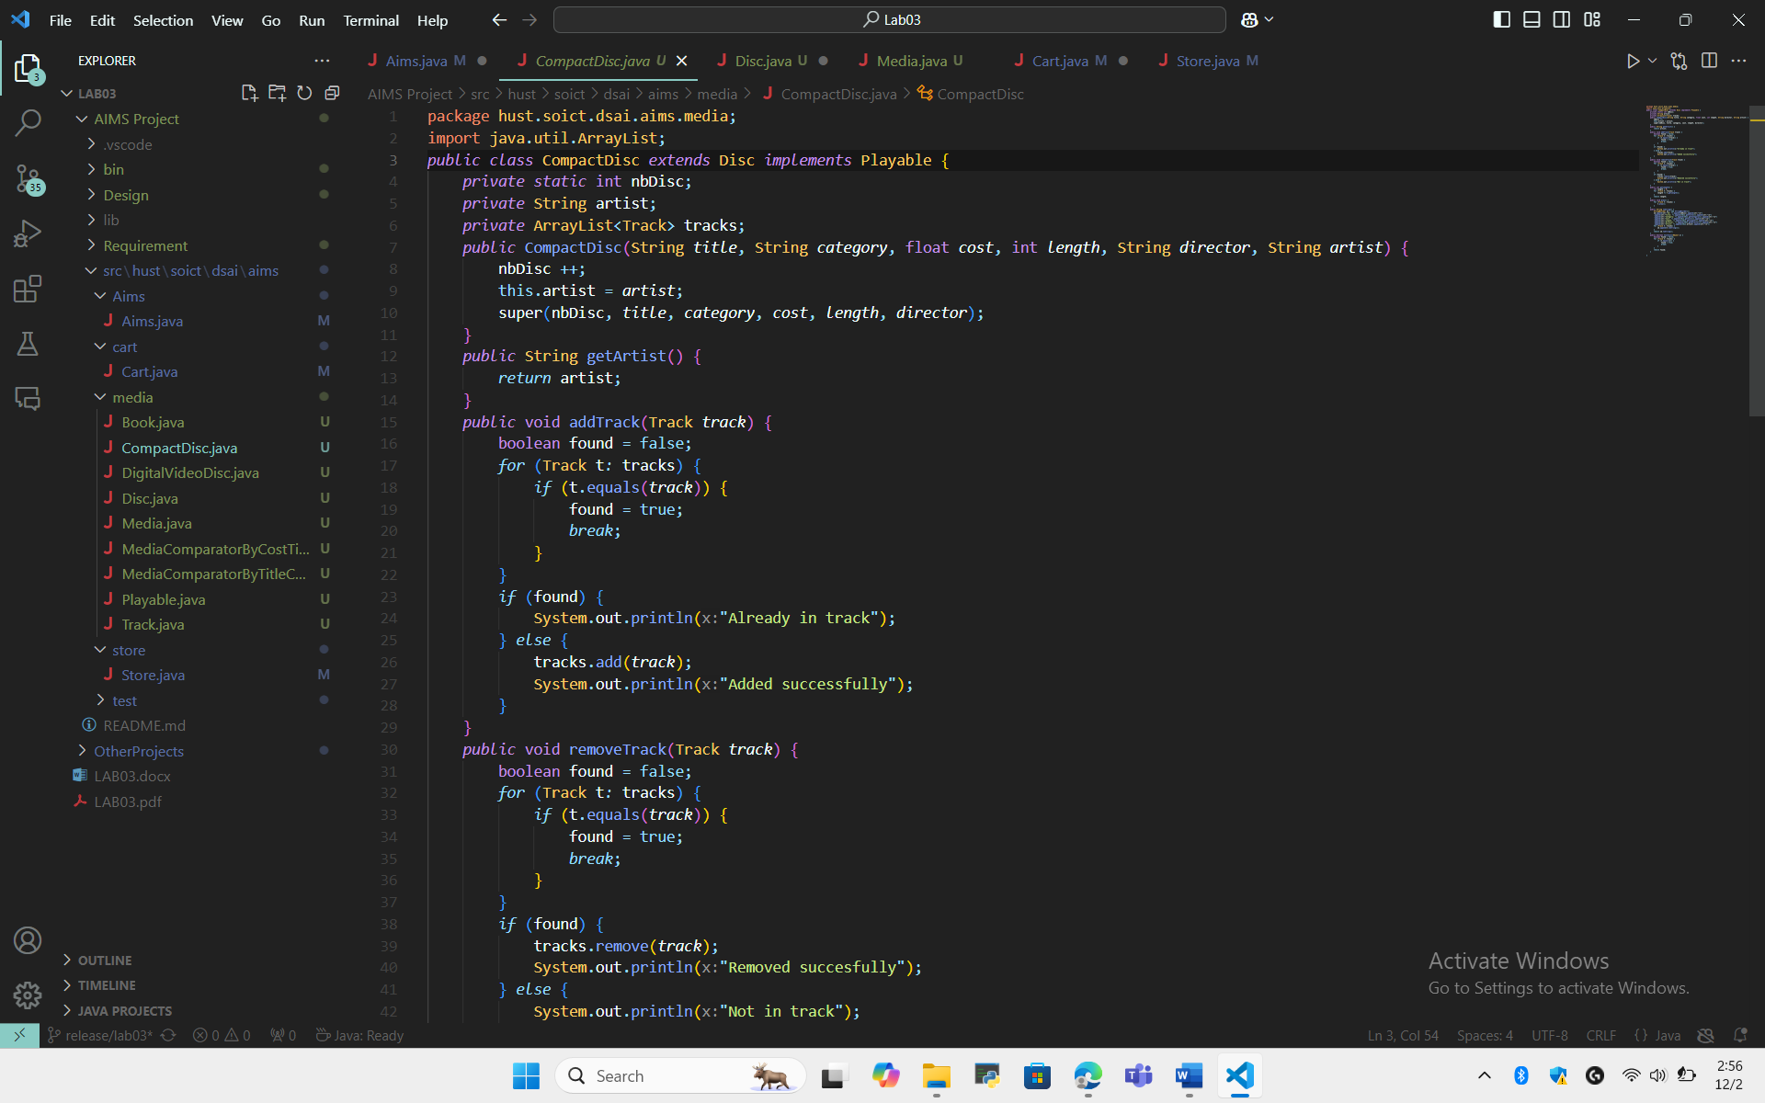
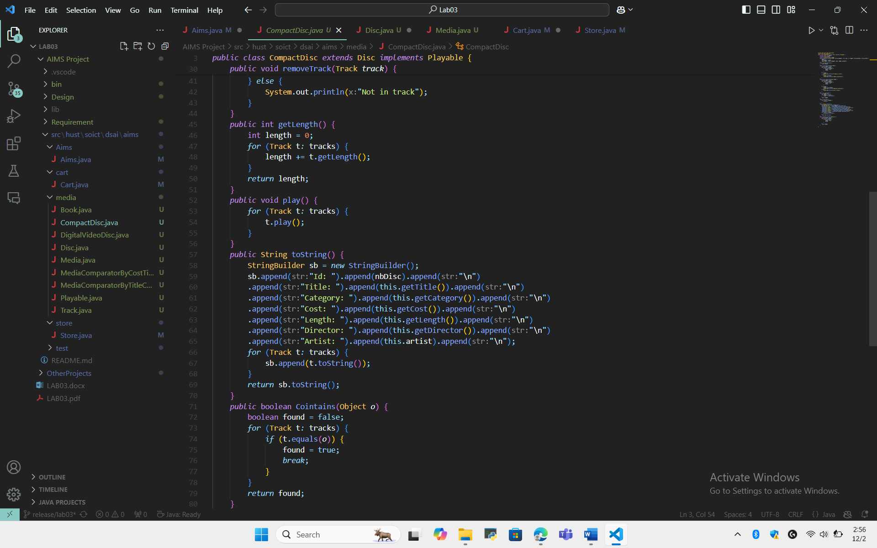

  - Book class
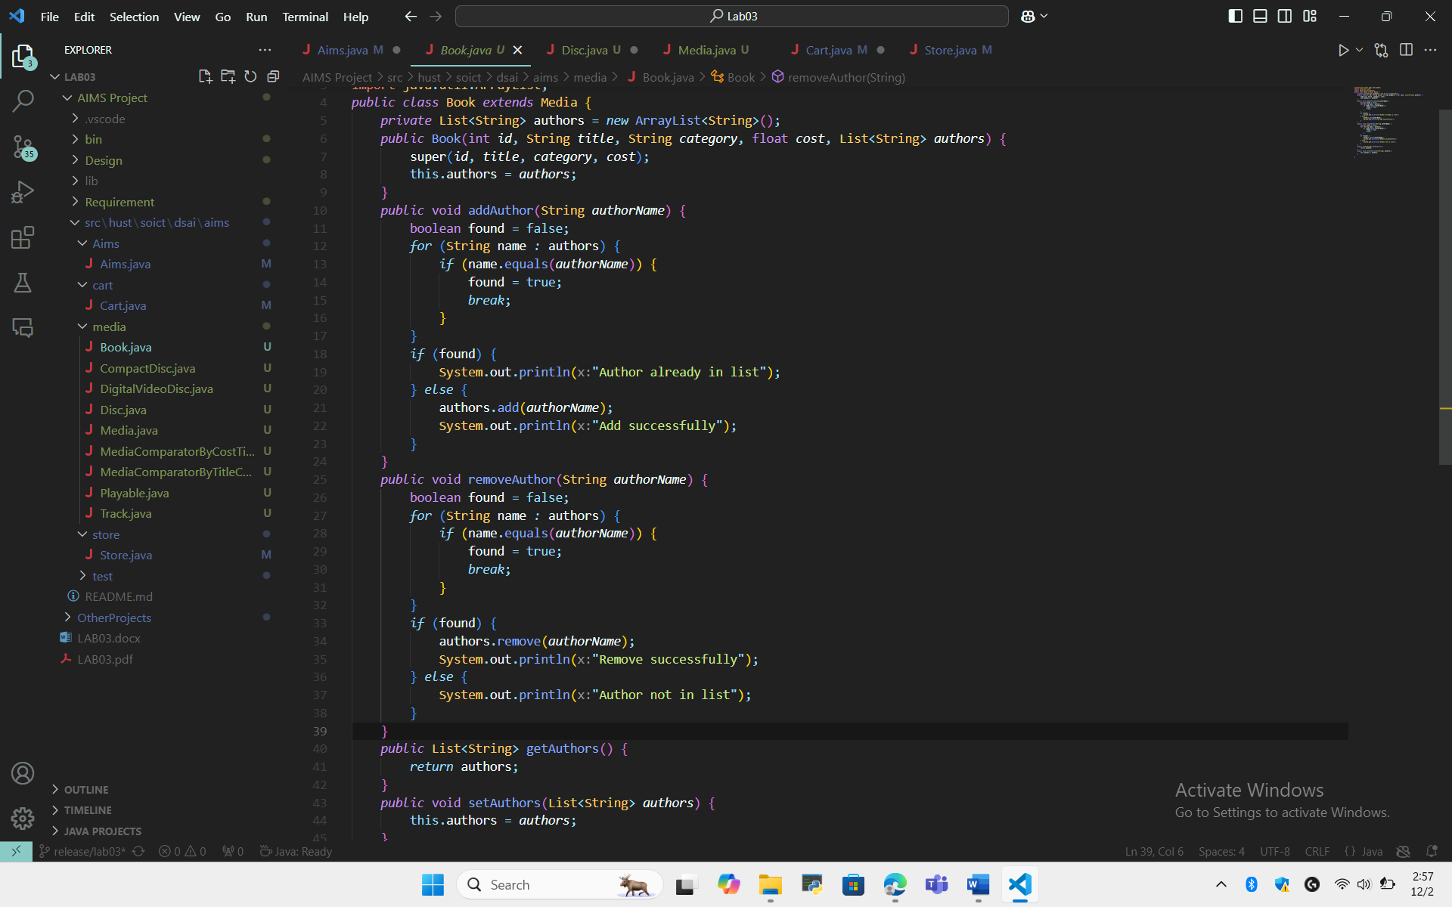

  - Track class
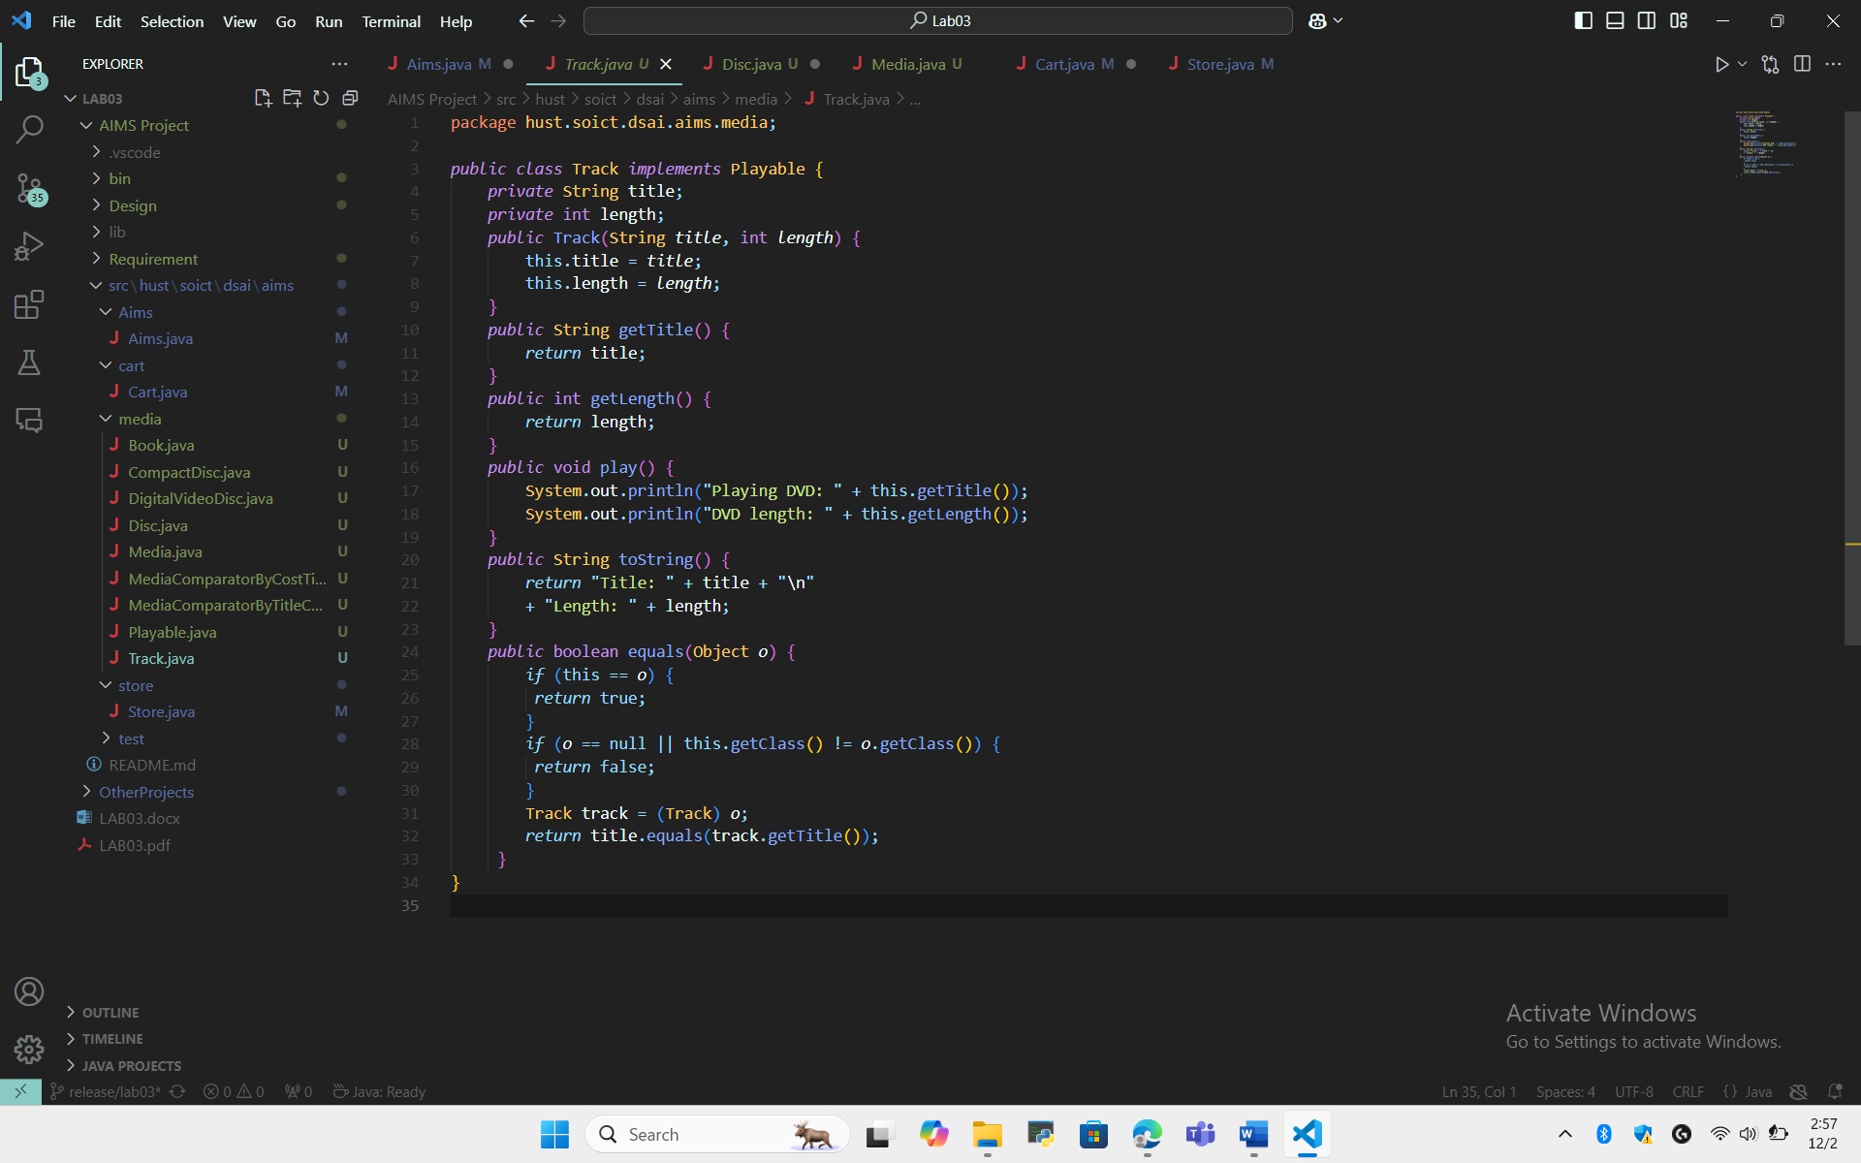
  - Interface playable

  - Comparator
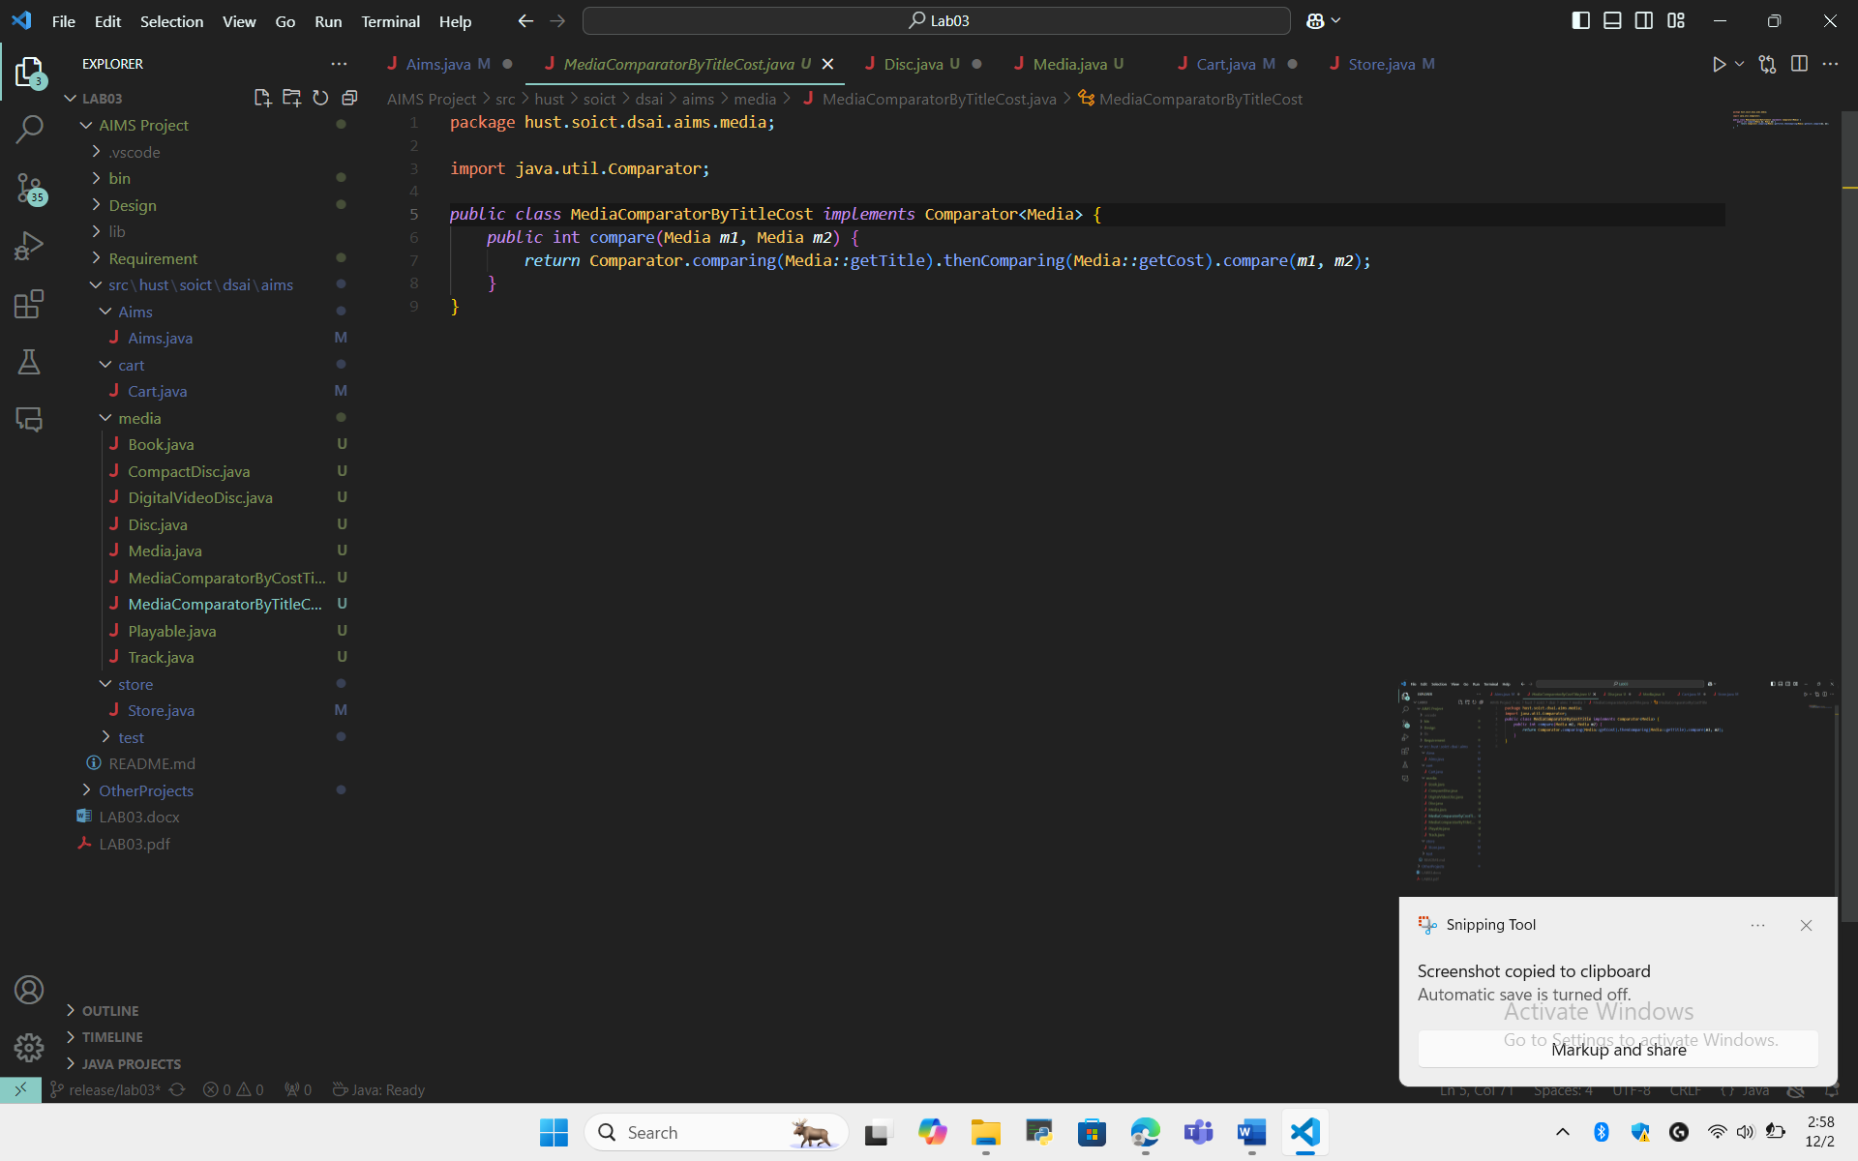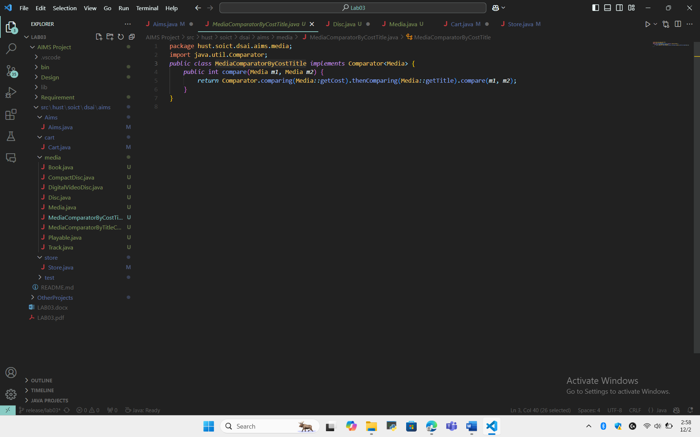

- Diagram
2.1 Class diagram


2.2 Usecase diagram
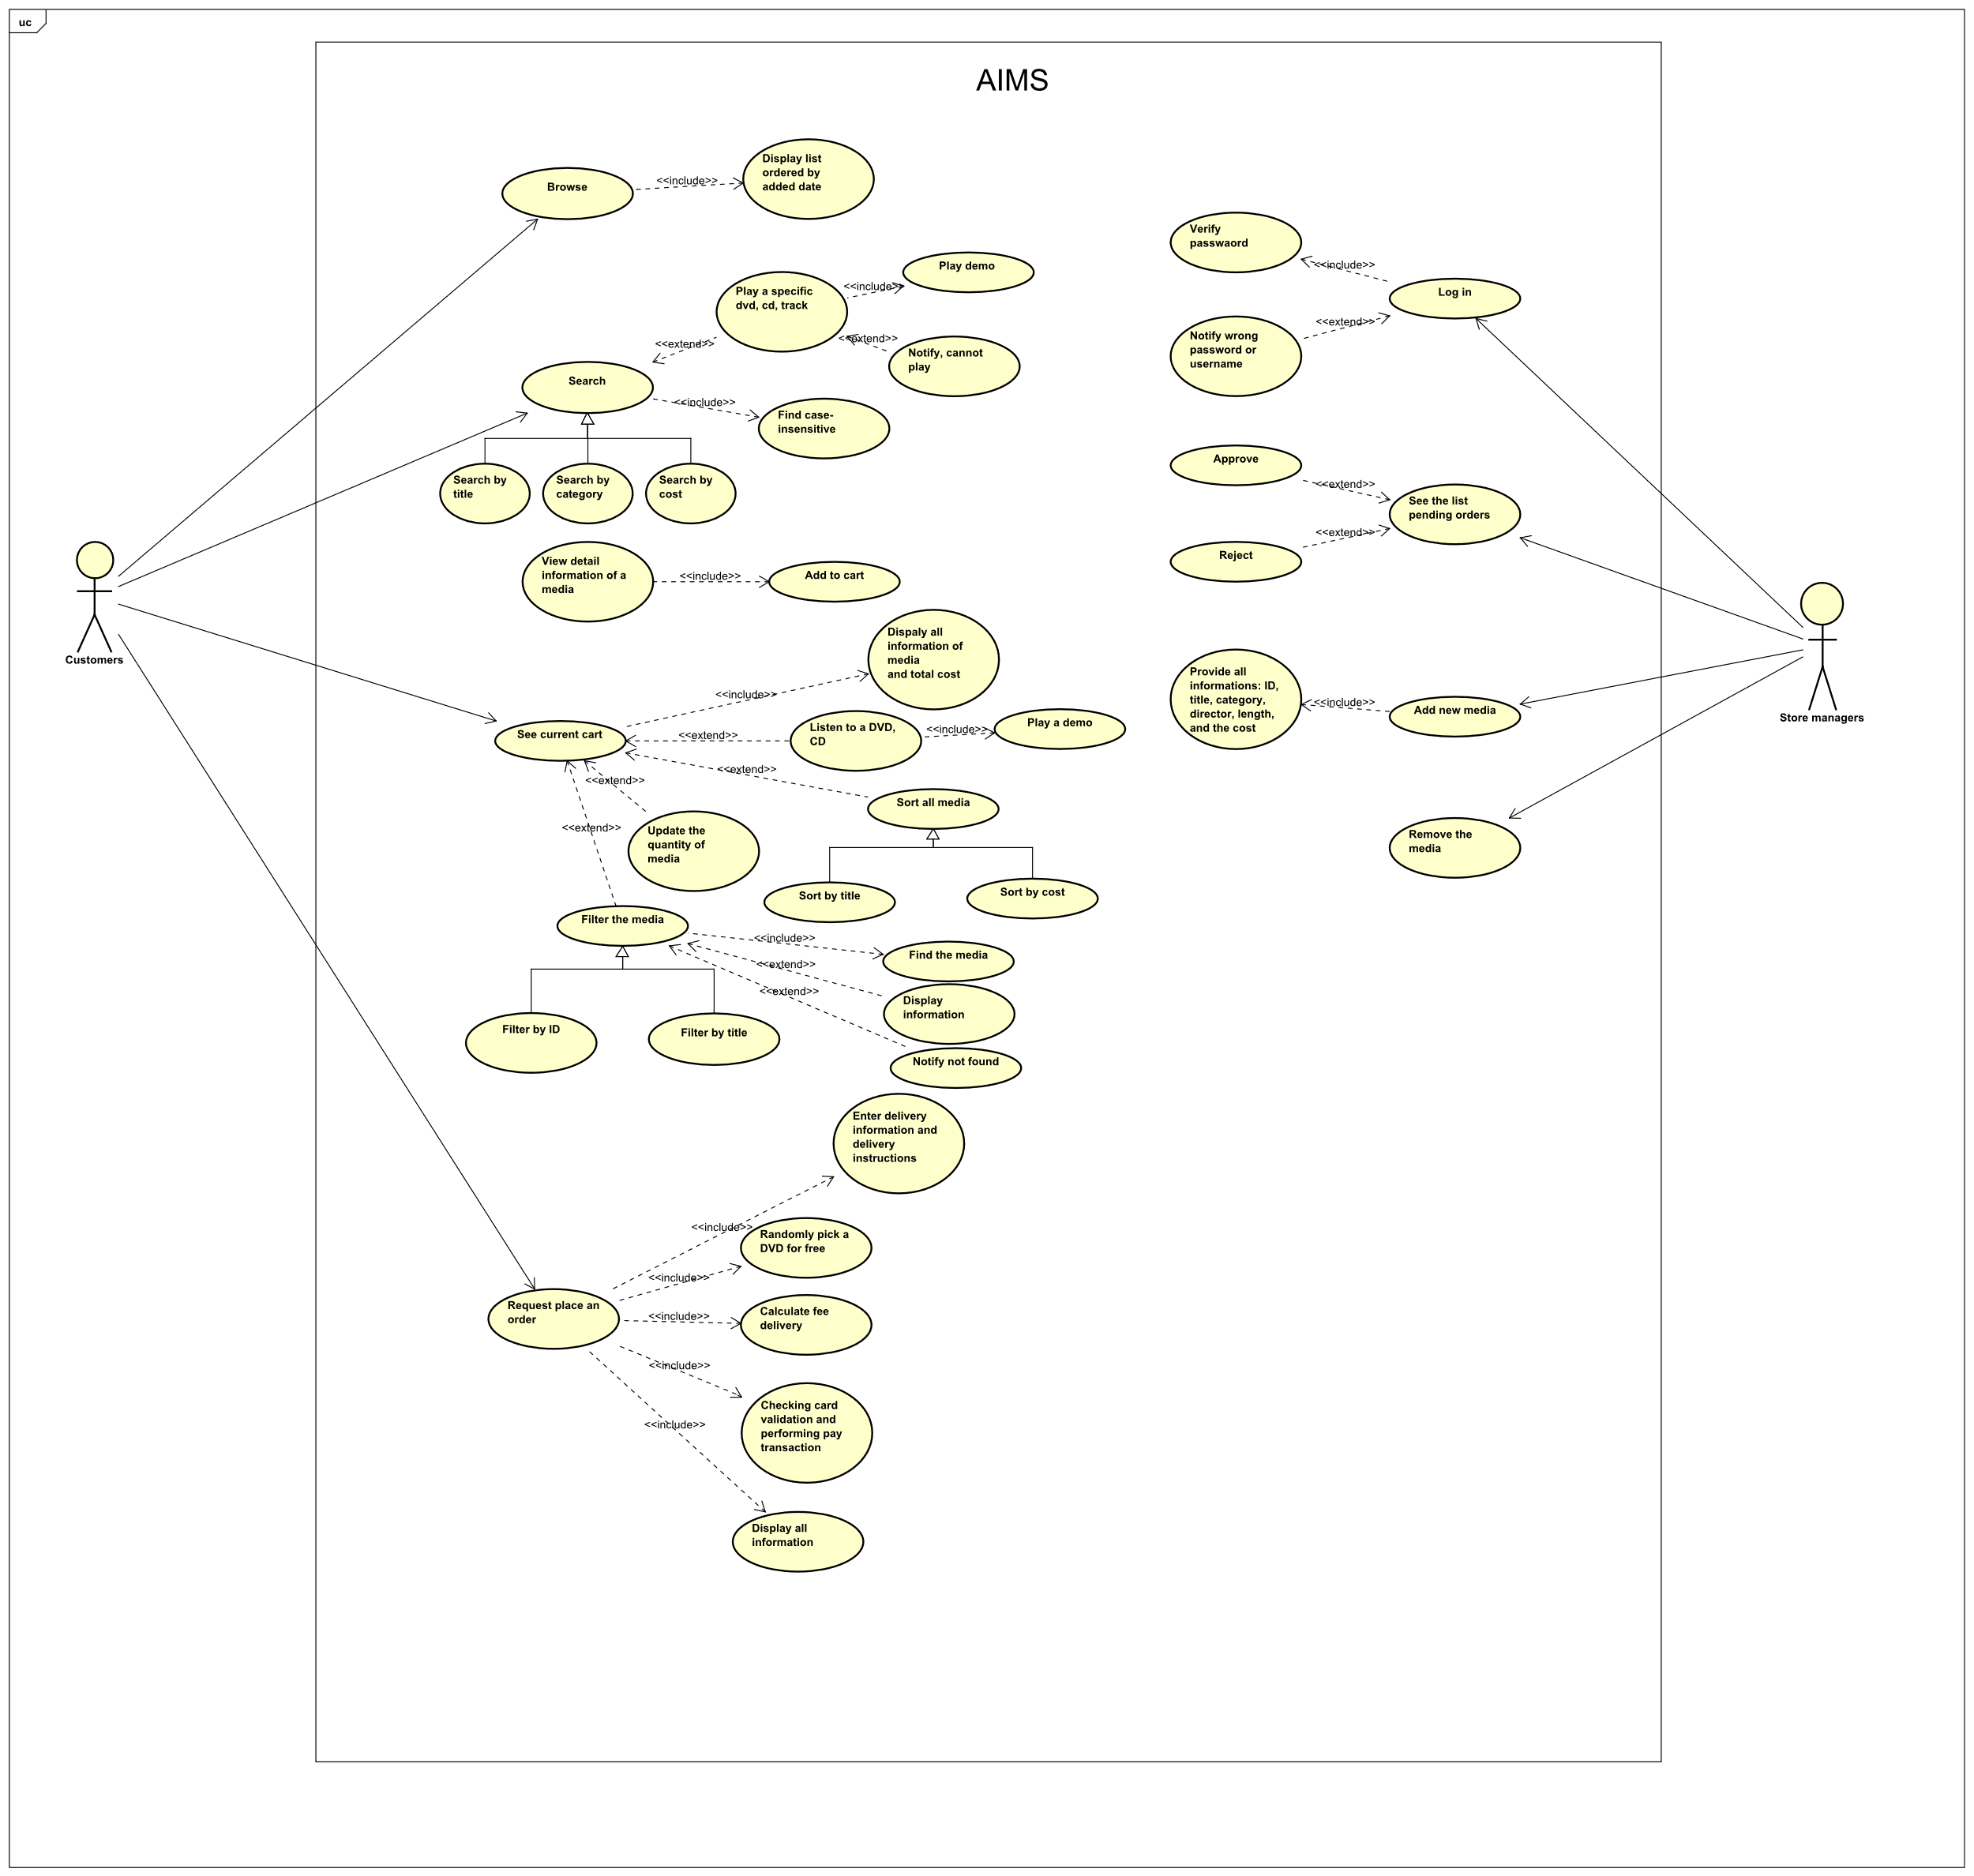

- Answer
3.1 Which classes are aggregates of other classes? Checking all constructors of whole classes if they initialize for their parts?

- Cart aggregates Media objects
- Store aggregates Media objects
- CompactDisc aggregates Track objects

3.2 When overriding the equals() method of the Object class, you will have to cast the Object parameter obj to the type of Object that you are dealing with. For example, in the Media class, you must cast the Object obj to a Media, and then check the equality of the two objects’ attributes as the above requirements (i.e. title for Media; title and length for Track). If the passing object is not an instance of Media, what happens?

- If the passing object is not an instance of Media, it will return false.

3.3 Question: Alternatively, to compare items in the cart, instead of using Comparator, we can use the Comparable interface and override the compareTo()method. You can refer to the Java docs to see the information of this interface.
Suppose we are taking this Comparable interface approach.
- What class should implement the Comparable interface?
- In those classes, how should you implement the compareTo()method be to reflect the ordering that we want?
- Can we have two ordering rules of the item (by title then cost and by cost then title) if we use this Comparable interface approach?
- Suppose the DVDs has a different ordering rule from the other media types, that is by title, then decreasing length, then cost. How would you modify your code to allow this?
- Class media should implement the Comparable interface and subclass of media class such as Book, Disc, DVD, CD should also override that method.
- Each class should override the compareTo() method to define the natural ordering, for example by title, by cost, …
- Using Comparable interface, a class can define only one ordering using compareTo() method.
- We should override this method for DVD class
